STATISTICAL REPORT ON THE CRABS DATA SET
The crabs data set is a morphological Measurements on Leptograpsus variegatus . The data collected at Fremantle, W. Australia.
DATA ANALYSIS
The crabs data is a data frame that contains 200 rows and 8 columns, describing 5 morphological measurements on 50 crabs each of two colour forms and both sexes, of the species Leptograpsus
The crabs data set has 8 variables in which 5 are numeric(frontal lobe size (mm),
rear width (mm), carapace length (mm), carapace width (mm)and body depth (mm)
,2 are factor (Species and sex) and 1 is an integer(index).
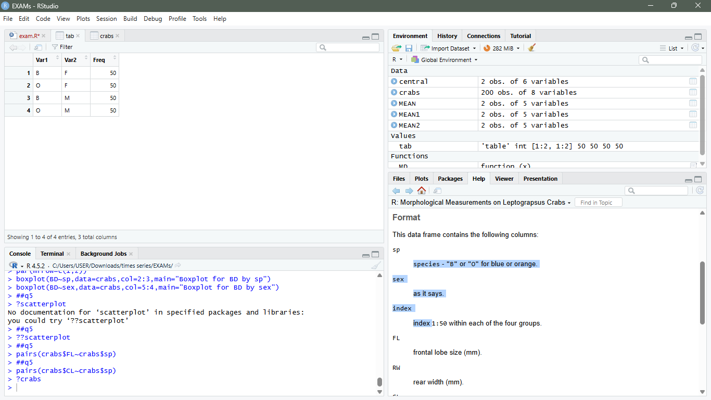.

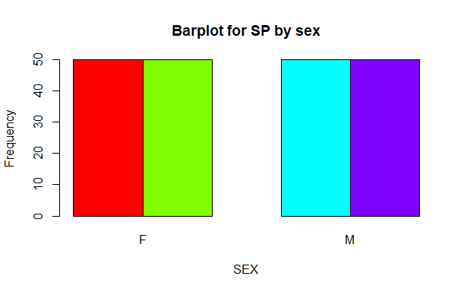
From the frequency table, it can clearly be seen that all species have a frequency of 50 and the bar chart also confirms it visually. Hence we can conclude that the data is balanced. The balance nature of the data makes it suitable for statistical analysis which will provide unbiased results.
2. a)
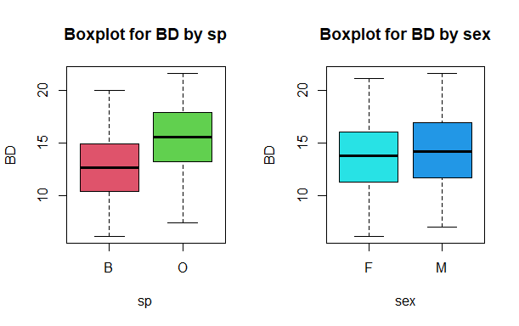
The boxplot of both species clearly shows that there are only few outliers for the body depth measurements of crabs. Furthermore, the median body depth of across species and sex are roughly close hence there is very little distinction between them. The variability in both cases are also fairly similar as well.
b. Mean1 Mean2 Median1 Median2 Mode1 Mode1.1 Variance
B 12.583 13.724 12.60 13.8 7.7 13.8 11.17720
O 15.478 14.337 15.55 14.2 17.9 17.8 12.20963
The O species has a more crabs with the most frequent body depth and also it is the Data with the most variability amongst the two.

3.
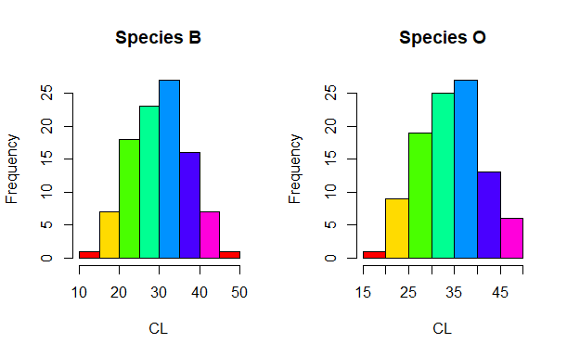
crabs$sp: B
[1] 0.02571518
---------------------------------------------------------------
crabs$sp: O
[1] -0.1536776

The histogram of species B and O are unimodal and visually it can be said that the shape is approximately symmetric with very slight skewness.
The skewness values of both species O and B are between 0.5 and -0.5, therefore it can be said that they are approximately symmetric with slight skewness.
4.
Means of species
m1 m2 m3 m4 m5
B 14.056 11.928 30.058 34.717 12.583
O 17.110 13.549 34.153 38.112 15.478
Mean of sex
mn1 mn2 mn3 mn4 mn5
F 15.432 13.487 31.360 35.830 13.724
M 15.734 11.990 32.851 36.999 14.337
5.
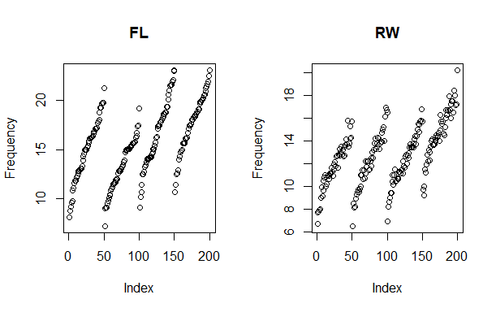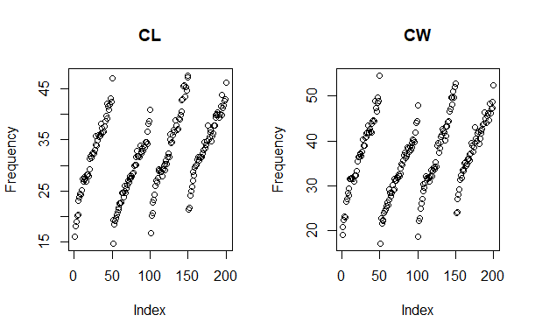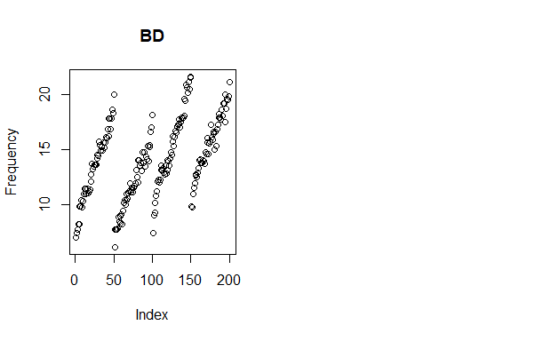
In all of the morphological measurements have strong positive correlation between themselves and the species and sex.

CONCLUSION
The crabs data set is a combination of morphological measurements of Leptograpsus variegatus. The data was a fairly balanced data which made analysis of the data quite realistic.
From the scatter plot shows a positive correlation between the measurements, the sex and species. From the descriptive statistics values, the Carapace Length seem to be the data with the largest distinction between groups across species and sex.

